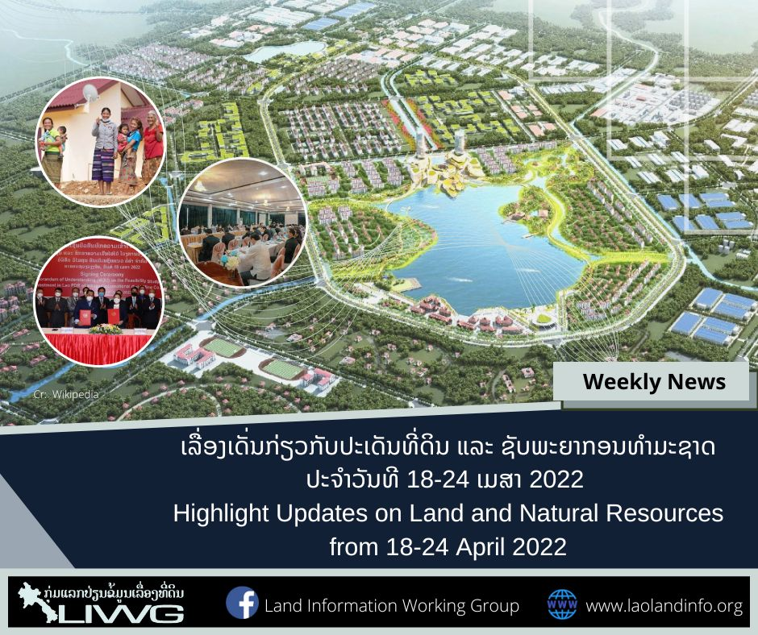
Land Information Working Group
www.laolandinfo.org
Follow us:
ຂ່າວພາສາລາວ
- ຫຼວງພະບາງໃຫ້ບໍລິສັດເອກະຊົນສຳປະທານດິນລັດ, ຂ່າວໂດຍ Vientiane Times: https://bit.ly/3KLAwB1
- “ໜຶ່ງແລວ ໜຶ່ງເສັ້ນທາງ” ມີບົດບາດສໍາຄັນໃນການພັດທະນາເສດຖະກິດຂອງປະເທດລາວ ແລະ ພາກພື້ນ, ຂ່າວໂດຍ Vientiane Times: https://bit.ly/3vJIXbv
- ປີ 2021 ສປປ ລາວ ສົ່ງອອກສິນຄ້າ ບັນລຸຫລາຍກວ່າ 7.600 ລ້ານໂດລາສະຫະລັດ, ຂ່າວໂດຍ KPL: https://bit.ly/3MS0RPb
- ສຳເລັດກອງປະຊຸມວຽກງານກວດກາທົ່ວປະເທດ ຄັ້ງທີ່ 4 ສຳລັບກະຊວງ-ອົງການອ້ອມຂ້າງສູນກາງ, ຂ່າວໂດຍ ເສດຖະກິດ-ສັງຄົມ: https://bit.ly/3yca80t
- ການສໍ້ລາດບັງຫຼວງແຕ່ປີ 2016 ເປັນຕົ້ນມາກໍ່ໃຫ້ເກີດຄວາມເສຍຫາຍ 8 ພັນຕື້ກີບ 50 ລ້ານໂດລາ 36 ລ້ານບາດ, ຂ່າວໂດຍ ເສດຖະກິດ-ສັງຄົມ: https://bit.ly/39rWfAL
- ທາບທາມການປັງປຸງກົດໝາຍ ວ່າດ້ວຍການແກ້ໄຂຄໍາຮ້ອງທຸກ, ຂ່າວໂດຍ KPL: https://bit.ly/3FsAAV3
- ສນຊ ຜັນຂະຫຍາຍເນື້ອໃນມະຕິ ກອງປະຊຸມວຽກງານຈັດຕັ້ງທົ່ວປະເທດ ຄັ້ງທີ XI, ຂ່າວໂດຍ KPL: https://bit.ly/3LUFbSw
- ຄະນະປະຈໍາສະພາແຫ່ງຊາດ ຮ່ວມກັບຄະນະ ລັດຖະບານ ຫາລືຫລາຍບັນຫາສໍາຄັນຮີບດ່ວນ, ຂ່າວໂດຍ KPL: https://bit.ly/3Fs0jgf

English News

ENVIRONMENTAL IMPACT ASSESSMENTS AREN’T PROTECTING THE ENVIRONMENT
- State Inspection Authority: USD 732 Million Lost to Corruption Since 2016, by Laotian Times: https://bit.ly/3yfCWVH
- Laos Cabinet and National Assembly Meet to Discuss Economic Woes, by Laotian Times: https://bit.ly/3FeSFFW
- Laos Records Bumper Trade Surplus in 1st Quarter, by Laotian Times: https://bit.ly/3vJIc29
- Authorities Acknowledge Waste Collection Problems in Vientiane Capital, by Laotian Times: https://bit.ly/3w47d7o
- Rising fuel price, depreciating kip harming Lao producers, by Vientiane Times: https://bit.ly/3FjFgfL
- Laos promotes renewable energy to achieve carbon neutrality, by Vientiane Times: https://bit.ly/3yfqkxV
- Riverbank erosion severe, hundreds of hectares lost every year: report, by Vientiane Times: https://bit.ly/3LOset8
- US support helps improve lives of people with disabilities, by Vientiane Times: https://bit.ly/3wpnHar
- Laos, Japan launch project to protect vulnerable groups, by Vientiane Times: https://bit.ly/3ya8Frs
- Private firm to study into possibility of investment projects in Laos, by KPL: https://bit.ly/3kJ1yhz
ຂ່າວຮອບໂລກ/Worldwide

US President Biden to Host ASEAN Leaders at Summit in May, by Laotian Times: https://bit.ly/3vLDgtU

Thai, Malaysian Firms Pull Out Of Myanmar Project, by the ASEAN Post: https://bit.ly/37tYkvy

Climate Change: Key UN Finding Misinterpreted, by the ASEAN Post: https://bit.ly/3weOkPa

SAC calls for peace talks with rebels in Myanmar, by Phnom Penh Post: https://bit.ly/3P5sKFl

The US president restores environmental safeguards ditched by a former president, by Phnom Penh Post: https://bit.ly/3vVBqqq
ວິດີໂອຂ່າວ/Video News & audio

